Meghann Remick
Visual Art Teacher
Belmont High School

Learning Excellence Grants Program
Award #: 19-35 LE
Award Title: Developing the Digital Art and Animation Program at Belmont High School

Final Project Article

The students in the Media Arts (Digital Art and Animation) program at Belmont High School have benefitted greatly from the addition of five iMac computers to the Media Arts studio. Students now have access to industry-standard technology and software; learning the tools and techniques that professionals use. The most significant accomplishment has been their progression from using the iPad and apps to working with the computer with full creative programs. Moving to this new technology offers many more complex and creative opportunities for art making. Growth in technology is essential to the success of the Media Arts program as it gives students access to the tools they need for this exciting medium.

Due to the large class sizes and limited work stations, students worked in partners to learn the basics of Photoshop. Partner groups rotated and practiced tools and techniques after teacher demonstrations. Each day, they completed checklists for the new tools and functions and submitted their work to Google Classroom. It has been wonderful to see students working together, helping each other, and discovering the amazing capabilities of Photoshop. At this point in the curriculum, they are now starting their first independent project in Photoshop: creating digital composites. The goal is to have students apply their knowledge of Photoshop as they take more creative risks and build on their skills to produce original art.

The project successes are many, but I have chosen to focus on collaboration, creative thinking, and advancement in technology. The computer station and programs will be utilized all year and beyond in the Media Arts and will ultimately include using more programs such as Adobe Illustrator and After Effects. We will continue to build and grow the program with computers and software. Many thanks for this generous FBE grant!

The following are examples of the partner work in learning the program Photoshop:
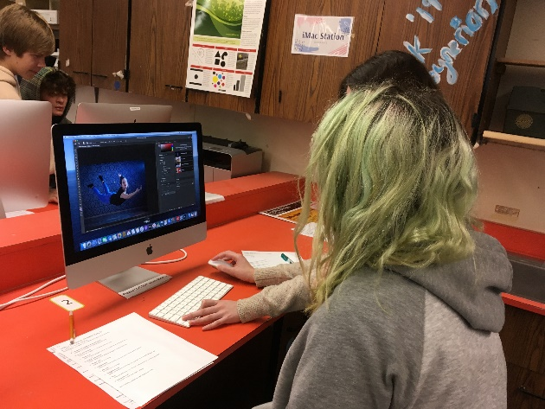 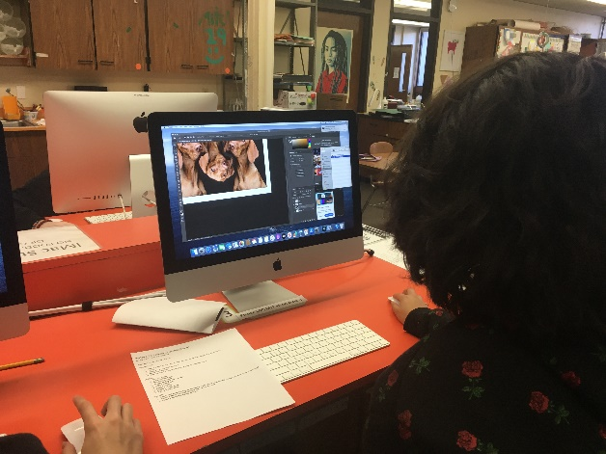
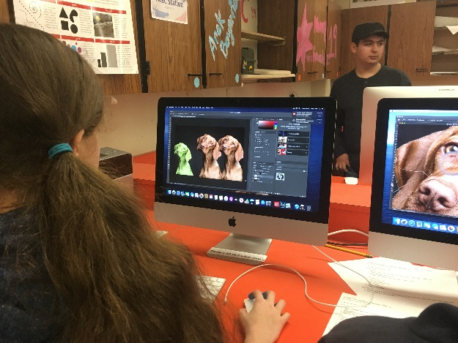 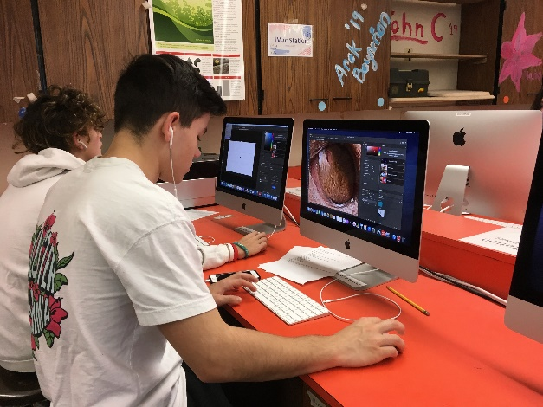
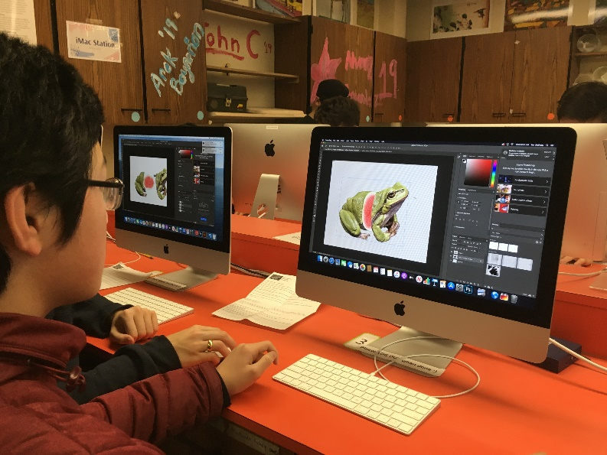
Photoshop Exercise: Frog-Slice! Compositing images
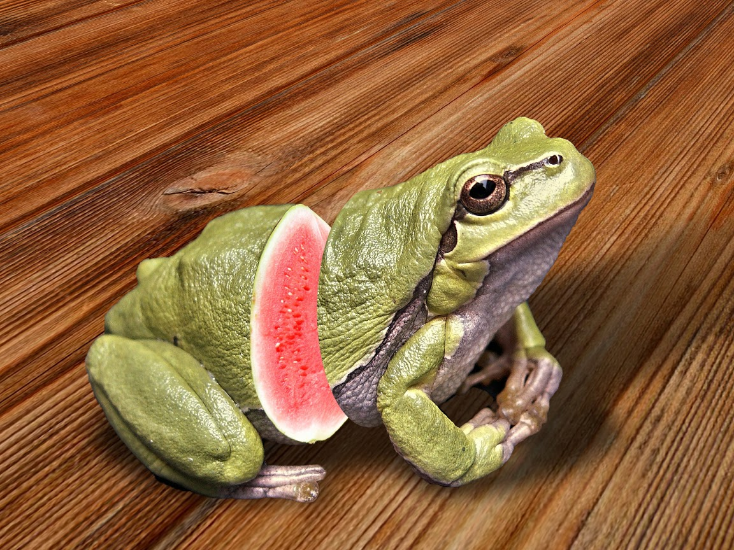

Example of the Photoshop Checklist:

Today’s Photoshop Checklist (Day 4)
My partner & I tried the following:
First: Use the dog image to start.
SELECTIONS:
- Make a selection with any of the selection tools. Cut and paste the Selection.
- UNDO
- Copy and Paste the Selection
- Move the Selection
- Transform the Selection (make it bigger or smaller/rotate)
LAYERS:
- Select a Layer
- Create a New Layer
- Duplicate a Layer
- Create an Adjustment Layer
- Make a New Layer
- Move a Layer
- Delete a Layer
- Create a Layer Mask
- Delete a Layer Mask
MASKING:
- Select and Mask the dog (working carefully on the edges), and change the color of the background.
- Select & Mask the child, paying attention to the hair
- Select & Mask the woman (trickier!)

